Lucy Finnegan: observation notes

I really loved watching your session, Lucy. There was a kind of secondary school vibe to it, and so it gave me a lot to think about: what that means, what’s good about that, what’s bad about that, etc. It was thought-provoking.

The energy and volume of your voice is invigorating, and congruent with your stated aim to keep them awake(!). The new LCF building can often be tricky for sound, as the air conditioning can be noisy, and you don’t have control over the windows. It’s quite quiet in this room, so you can probably take it down a notch. You could try experimenting with a deeper tone. This would make this easier on your larynx and on their ears, as lower frequencies carry much further and reduce aural overstimulation. Lower vocal frequencies also bear sociopsychological associations with authority (go figure...)! Did you know that the African elephant produces a call which is so low in pitch that it’s inaudible to humans (around 20Hz)? These calls travel up to 10km! You might try picturing yourself as a (glamorous, obvs) lady elephant.

I love that this commonly-used classroom layout is referred to as ‘cabaret’ because for me it doesn’t merely describe the placement of tables and people. It also says something more profound about power, expectation and ambiguity. You are the performer, sometimes up on the stage and sometimes moving around engaging with the audience, but there is some ambiguity in whether the audience are expected to attend to you, or to each other. In real cabaret, this expectation may be signaled by changes in the music and lighting, and the performer’s position. We don’t have those tools in the classroom so we have to think about our signaling carefully. For example, when you were engaging directly with the inside table you were still speaking in your whole room voice, but the girls on the outermost table by the window started talking to each other. The other tables were then plunged into uncertainty. Were there supposed to be listening to your exchange with the inner table, or having their own discussions? Another key difference between teaching and cabaret is that the conversations students have on their tables have generally been set by ourselves. It can therefore seem inconsistent or even demanding to set them off on a task and then require them to momentarily switch their attention back onto us, and in my experience they don’t.

It’s always going to happen that once you’ve set a group task and they’re getting on with it, things will come up that they missed, or that you forgot to tell them (or even just that you need to tell them they have three minutes left). My advice is to resist the temptation to raise your voice over the hubbub. For starters, it indicates an assumption that what you’re saying is more important than what they’re saying. It’s a dynamic that will be familiar to the UK students from their school years, and they won’t all fall silent and listen to you, they are all halfway through their sentences and may only register your voice as ‘noises off’, like construction noise. You will get the nagging sense that you’re being ignored or shouting into a void. What can you do instead? For timekeeping you can write ‘5 mins left’ on a whiteboard or slide or use a countdown timer. My preferred strategy for checking in and redirecting is to creep around the room whispering and gesturing in a subservient, apologetic manner — I’m exaggerating of course; the point is to communicate, through body language and tone of voice, that of course what they are saying to each other is of the utmost importance, and I am just the facilitator.

Your use of props is super; by having a physical pair of flip-flops on each table you’re undertaking a form of object-based learning, which brings the attendant benefits of focus and presence.

I loved the rapport you showed when you asked them who Connor Ives was going to prefer; this was a great opportunity to emphasise the power and capital their generation has, and also to share a little vulnerability; that you know your experience doesn’t always bear currency.

I initially misunderstood the Who What Why When Where How task. I thought it was a set of prompts to help them to think through their story, but it seems it was a tool to help them to structure their presentations. Maybe I still don’t have it right! Did they get it? If not, can you model it for them somehow? Ideally on a worksheet on the tables so you don’t have to stand up the front explaining it when half the class already understand.

You ask a lot of questions that have a specific answer you’re seeking. This is working in the sense that you are getting answers from some people, i.e. you’re not winding up in a situation like the history teacher in Ferris Bueller’s Day Off: <https://youtu.be/uhiCFdWeQfA?feature=shared>

[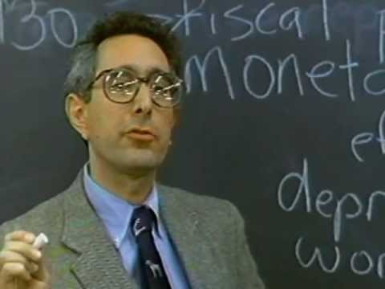](https://youtu.be/uhiCFdWeQfA?feature=shared)

However, even when the Q&A is ‘working’, it is also divisive. The intention is good; it’s to invite the students to participate in the delivery of facts. However, those who don’t know the answers are likely not engaged in learning the answers; they’ll likely just be *worrying about why they don’t know the answers*. Remember the old saying – people won’t remember what you told them; they’ll remember how you made them feel. There are better ways of finding out what they already know or remember, there are better ways of sharing facts, and there are better ways of inviting participants to construct their learning. My advice to anyone would be to avoid this kind of Q&A altogether 😊

At 9.37 you handed over to Joe Delaney who is a short filmmaker who also works for NOWNESS. He gives a presentation to give a sense of his own realm of work and gives them some more clues about what we mean by a fashion story. He emphasises that a story can be narrative, documentary, non-linear (depicting fragments/moments), or abstract (communicating a feeling – e.g. some perfume ads).

I’d love to hear your thoughts about the session and my notes from it. Thank you for having me along!